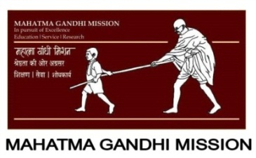

**MGM’s POLYTECHNIC, AURANGABAD**

**2020-2021**

Micro Project Report

On

**“Case study on Intersection of solids”**

Submitted in partial fulfillment for ‘I’ Scheme second semester of

**Diploma in**

**MECHANICAL ENGINEERING**

**By**

**DHAKNE RAMAKANT MAHENDRA ( 1915010275 )**

**MOHAMMED SAAD SAYYED ( 1915010276 )**

**JADHAV SWARAJ MILIND ( 1915010277 )**

Under the guidance of

**Prof. Kakde D V**

(Lecturer in Mechanical Engineering)

***In Pursuit of Excellence***



[**Maharashtra State Board of Technical Education, Mumbai**](http://msbte.org.in/)

**(Autonomous) (ISO-9001-2008) (ISO/IEC 27001:2013)**



**Maharashtra State**

**Board of Technical Education, Mumbai**

**Certificate of Completion**

This is to certify that Mr./Ms. ..DHAKNE RAMAKANT MAHENDRA , MOHAMMED SAAD SAYYED ,JADHAV SWARAJ MILIND **with Enrollment No 1915010275 , 1915010276 , 1915010277 has successfully completed his/her Micro-Project entitled " Case study on Intersection of solids " in the Course/Subject of " Mechanical-Working-Drawing (22341) "in the second semester during his/her tenure of completing the Diploma programme in Mechanical Engineering From MGM's Polytechnic institute with institute code 1501.**

**Prof. Kakde D V Prof. Bhalekar B.D**

**Guide HOD**

Mechanical Engineering Mechanical Engineering

**Dr. B.M. Patil**

**Principal**

**INDEX**

|  |  |  |
| --- | --- | --- |
| **Sr. No.** | **Content** | **Page No.** |
| **Micro-Project Proposal (ANNEXURE-I)** | |  |
| 1.0 | Aims/Benefits of the Micro-Project | 4 |
| 2.0 | Course Outcomes Addressed | 4 |
| 3.0 | Proposed Methodology | 4 |
| 4.0 | Action Plan | 4 |
| 5.0 | Resources Required | 5 |
|  |  |  |
| **Micro-Project Report (ANNEXURE-II)** | |  |
| 1.0 | Rationale | 6 |
| 2.0 | Aims/Benefits of the Micro-Project | 6 |
| 3.0 | Course Outcomes Achieved | 7 |
| 4.0 | Literature Review | 7 |
| 5.0 | Actual Methodology Followed | 9 |
| 6.0 | Actual Resources Used | 9 |
| 7.0 | Outputs of the Micro-Projects | 10 |
| 8.0 | Skill Developed / Learning outcomes of this Micro-Project | 10 |
| 9.0 | Applications of this Micro-Project | 10 |

**Annexure – I**

**Micro-Project Proposal**

**Case study on Intersection of solid**

1. **Aims/Benefits of the Micro-Project**

Aim of drawing these curves:- When two objects are to be joined together, maximum surface contact between both becomes a basic requirement for strongest & leak-proof joint. Curves of Intersections being common to both Intersecting solids, show exact & maximum surface contact of both solids.

**2.0 Course Outcomes Addressed**

* Draw intersection curves of different solids

1. **Proposed Methodology**

* First we collect all the information about our micro project
* We also discuss the some related points about our topic with our faculty
* We have done we make a plane to make a model on the topic
* We make the model and shown to the respected faculty
* And then we make the report on that
* At last we have given our report and model to the faculty

**4.0 Action Plan**

|  |  |  |  |  |
| --- | --- | --- | --- | --- |
| **S. No.** | **Details of activity** | **Planned Start date** | **Planned Finish date** | **Name of Responsible Team Members** |
|  | Finalization of Micro Project Team | 13th Oct 2020 | 15th Oct 2020 | Mohammed saad |
|  | Finalization of Topic | 16th Oct 2020 | 17th Oct 2020 |  |
|  | Literature Survey | 18th Oct 2020 | 19th Oct 2020 |  |
|  | Submission of Micro-Project Proposal (ANNEXURE-I) | 19th Oct 2020 | 20th Oct 2020 | Swaraj jadhav |
|  | Proposed Methodology | 21st Oct 2020 | 24th Oct 2020 |  |
|  | Collecting Resources Required (raw material) | 25th Oct 2020 | 27th Oct 2020 |  |
|  | Making of Prototype/Working Model | 28th Oct 2020 | 31st Oct 2020 | Ramakant dhakne |
|  | Submission of Micro-Project Report (ANNEXURE-II) | 1st Nov 2020 | 2nd Nov 2020 |  |
|  | Presentation via PPT to Institute | 3rd Nov 2020 | 5th Nov 2020 |  |

**5.0 Resources Required**

|  |  |  |  |  |
| --- | --- | --- | --- | --- |
| **S. No.** | **Name of Resource/material** | **Specifications** | **Qty.** | **Remarks** |
|  | Google chrome | Research of the topic | 1 |  |
|  | Cardboard sheet | Making of the model | 2 |  |
|  | Glue | Pasting of the model | 1 |  |

**Name of Team Members with Roll Nos.**

1. DHAKNE RAMAKANT MAHENDRA , ( 22113 )
2. MOHAMMED SAAD SAYYED ( 22114 )
3. JADHAV SWARAJ MILIND ( 22115 **)**

**\*\*\*\*\*\*\*\*\*\*\*\*\*\***

**Annexure – II**

**Micro-Project Report**

**Case study on Intersection of solid**

1. **Rationale**

CASES OF INTERSECTION The cases of intersection depend on the type of intersecting solids and the manner in which they intersect. Two intersecting solids may be of the same type (e.g., prism and prism) or of different types (e.g., prism and pyramid). The possible combinations are shown in Table below.

* 
* The two solids may intersect in different ways. The axes of the solids may be parallel, inclined or perpendicular to each other. The axes may be intersecting, offset or coinciding. Therefore, the following sub-cases exist:
* (i) Axes perpendicular and intersecting
* (ii) Axes perpendicular and offset
* (iii) Axes inclined and intersecting
* (iv) Axes inclined and offset

1. **Aims/Benefits of the Micro-Project:**
2. Manufacture of tables, chairs,
3. installation of air conditioning ducts,
4. in the construction of boilers, furnaces, chimneys,
5. connecting pipe to a cylinder,
6. making a tee joint in a pipe line,
7. arm of a person going into the main body.
8. **Course Outcomes Achieved**
9. Identify parts where concepts of intersection of the given solids is required
10. Draw curves of intersection of the given solid combination
11. Draw intersection curves of the different solids
12. **Literature Review**

* The type of intersection created depends on the types of geometric forms, which can be two- or three dimensional. Intersections must be represented on multi view drawings correctly and clearly. For example, when a conical and a cylindrical shape intersect, the type of intersection that occurs depends on their sizes and on the angle of intersection relative to their axes. The line of intersection is determined using auxiliary views and cutting planes
* Methods – (1) Line and (2) Cutting-plane methods Line method:

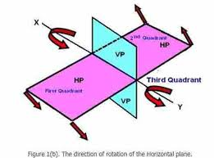

* A number of lines are drawn on the lateral surface of one of the solids and in the region of the line of intersection.
* Points of intersection of these lines with the surface of the other solid are then located.
* These points will lie on the required line of intersection. They are more easily located from the view in which the lateral surface of the second solid appears edgewise (i.e. as a line). The curve drawn through these points will be the line of intersection.
* Cutting-plane method: The two solids are assumed to be cut by a series of cutting planes. The cutting planes may be vertical (i.e. perpendicular to the H.P.), edgewise (i.e. perpendicular to the V.P.) or oblique. The cutting planes are so selected as to cut the surface of one of the solids in straight lines and that of the other in straight lines or circles.
* **Intersection of two prisms**
* The line of intersection between Two plane surfaces is obtained By locating the positions of Points at which the edges of one Surface intersect the other Surface and then joining the Points by a straight line. These Points are called *vertices* The line of intersection between Two prisms is therefore a closed Figure composed of a number of Such lines meeting at the Vertices
* 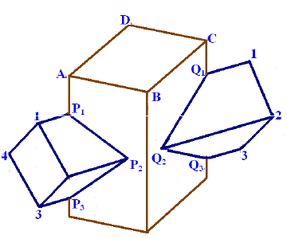
* 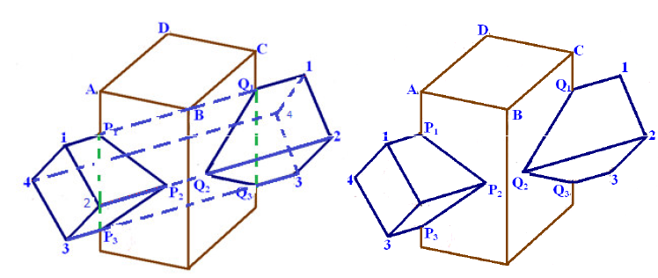
* A vertical square prism, base 50 mm side, is completely penetrated by a horizontal square prism, base 35 mm side, so that their axes intersect. The axis of the horizontal prism is parallel to the prism., while the faces of the two prisms are equally inclined to the prism. Draw the projections of the solids, showing lines of intersection. (Assume suitable lengths for the prisms.)
* Steps:
* Draw the projections of the solids, showing lines of intersection. (Assume suitable lengths for the prisms.) prisms in the required position. The faces of the vertical prism are seen as lines in the top view. Hence, let us first locate the points of intersection in that view.
* 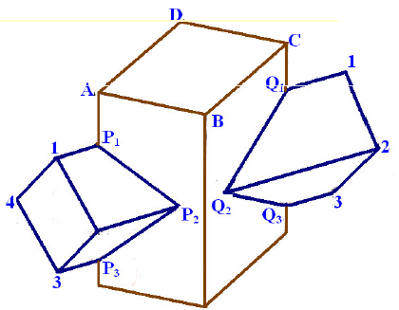
* Steps:
* Lines 1-1 and 3-3 intersect the edge of the vertical prism at points *p1* and *p3* (coinciding with *a).* Lines 2-2 and 4-4 intersect the faces at *p2* and *p4* respectively.
* The exact positions of these points along the length of the prism may now be determined by projecting them on corresponding lines in the front view. For example, *p2* is projected to *p2'* on the line 2'2'. Note that *p4'* coincides with *p2'*
* Intersection of two prisms
* Draw lines p1’p2' and p2‘p3'. Lines p1‘p4' and p3‘p4' coincide with the front lines. These lines show the line of intersection. Lines q1'q2' and q2‘q3' on the other side are obtained in the same manner
* Note that the lines for the hidden portion of the edges are shown as dashed lines. The portions p1’p3' and q1’q3' of vertical edges a'a' and c'c' do not exist and hence, must be removed or kept fainter
* 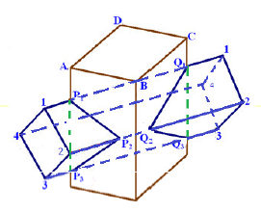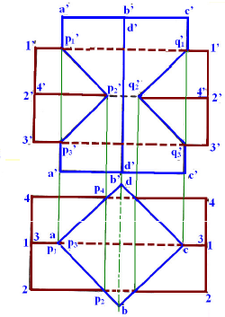

**5.0 Actual Methodology Followed**

1. Firstly we have got our topic on micro project
2. We have discuss with the respected sir
3. They give some suggestion about the work
4. We also search the topic on Google for more details
5. Then we discuss the topic with the team member
6. After collecting all the data we collect all materials for the model
7. We bring some cardboard, glue, paint , etc.
8. We make the model and present it to the sir
9. After approval of the model we start typing report on the topic
10. We make the report and finalize the correction form the sir
11. After the all correction and details we submit the model and the report to the respected sir

**6.0 Actual Resources Used**

|  |  |  |  |  |
| --- | --- | --- | --- | --- |
| **S. No.** | **Name of Resource/material** | **Specifications** | **Qty.** | **Remarks** |
|  | Google chrome | Research of the topic | 1 |  |
|  | Cardboard sheet | Making of the model | 2 |  |
|  | Glue | Pasting of the model | 1 |  |

**7.0 Outputs of the Micro-Projects** (Drawings of the prototype, drawings of survey, presentation of collected data, findings etc.)



**8.0 Skill Developed / Learning outcomes of this Micro-Project**

* **We have learn about the intersection of the solids**
* **We also draw some drawing of the prism , pyramid , etc.**
* **We have learn how to first make drawing on the sheet of metal and then after cutting how to make a model**
* **This is also use in making of different thing in the daily life**
* **We also the team work and how to coordinate with the shopkeeper**
* **We see the different types of intersection of solids**
* **This is also helped in our studies for understanding the concepts**

**9.0 Applications of this Micro-Project**

* A basic requirement for strongest & leak-proof joint
* A machine component having two intersecting cylindrical surfaces with the axis at acute angle to each other.
* An Industrial Dust collector. Intersection of two cylinders.
* Forged End of a Connecting Rod
* Intersection of a Cylindrical main and Branch Pipe.

**10.0 Reference**

* Engineering drawing ( Bhatt N.D )
* Machine drawing ( Panchal V.M )
* Mechanical working Drawing ( S Chand )